Towards a More Sustainable Environment:
Addressing Poverty for Women of Color and Their Children

Introduction
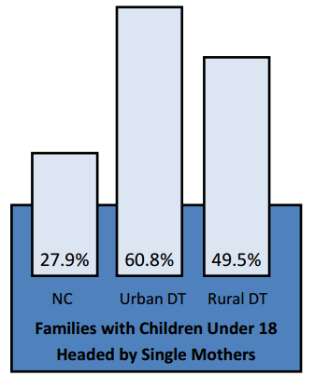
Our environment encompasses the earth we walk on and the air we breathe. It’s the communities we live in and the people we surround ourselves with. Time and time again, environmental conditions have been proven to affect health. It has been shown that social determinants and influences on health operate through many different processes, one of which is the type of area or neighborhood in which people live (Diez Roux, 2011). Social scientists have examined how living in areas of concentrated poverty influences individual-level outcomes such as employment and single parenthood. Neighborhood differences are especially relevant in trends of increasing concentrated poverty with other forms of disadvantage (Diez Roux, 2011). Racial residential segregation, a manifestation of racism, has been proven to affect access to education and employment opportunities, as well as creating conditions that are harmful to health in social and physical environments (Williams, 2001). A study done in Scotland found that neighborhood areas differed in terms of access to public and private transportation, exposure to personal and property crime, amenities, neighborliness, and litter (Williams, 2001). Additional research has found that poor, segregated neighborhoods are also characterized by high mobility, low occupancy rates, high levels of abandoned buildings and grounds and inadequate municipal services including police and fire protection (Williams, 2001).
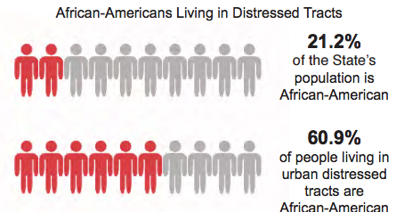
In North Carolina, women of color and their children are disproportionately represented in such disadvantaged communities. According to a study done by the William High in 2013 for the Center for Urban and Regional Studies at UNC Chapel Hill, based on information provided by the U.S. Census Bureau (see graphic to the above), it was found that in urban distressed tracts in North Carolina, over 60 percent of families with children were headed by single mothers. An urban distressed tract represents the most concentrated poverty. According to High, an urban distressed tract is characterized by unemployment rates greater than 50 percent of North Carolina’s unemployment rate, annual per capita income 1/3 lower than North Carolina’s per income of $25,256, and poverty rates 50 percent greater than North Carolina’s poverty rates. Of those households, people of color are disproportionately represented. High’s study (see graphic above) found that 60.9 percent of people living in urban distressed tracts are African American.
Center for Urban and Regional Studies, 2013
Center for Urban and Regional Studies, 2013
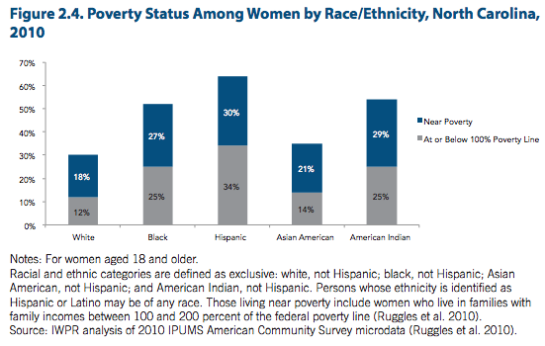
An analysis done by the Institute for Women’s Policy Research found that women in North Carolina are more likely than men, to live below the federal poverty line (Hess, 2013). In 2010, 17 percent of women and 13 percent of men, aged 18 and older in North Carolina, were poor (Hess, 2013). As the figure to the right illustrates, among women, Hispanics are the most likely to be poor, with 34 percent of them living in poverty; followed by black and American Indian women, each representing 25 percent, Asian American women at 14 percent, and white women at 12 percent (Hess, 2013).
With levels of concentrated poverty on a consistent rise in urban North Carolina, the lack of resources and government services is negatively affecting women’s health and well-being. A study found that African-American mothers’ perception of their stress levels in their residential environment can cause very low birth weight in newborns (Collins, 1998). Another study done in Durham and Wake County found that racial disparities between birth outcomes is an issue that continues to persist in the United States (O’Campo, 2008). A number of these studies have linked neighborhood characteristics to poor health outcomes - issues that are becoming more prevalent in communities of color. There is a desperate need to address health disparities as a result of built environment, while recognizing race as an active component to such disparities. If North Carolina wants healthier and more sustainable communities, they must address the issues affecting women of color and provide them with better opportunities. Through the introduction of a housing mobility program, women of color and their babies will be allowed to move out of low-income communities and into neighborhoods with better resources, thereby providing them with opportunities not originally available to them. It will provide women and their families the services and guidance they need for positive well-being.

History
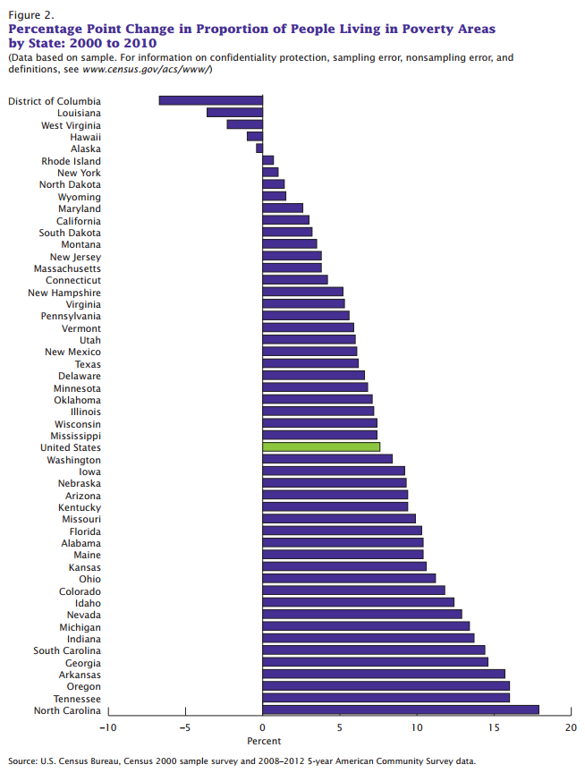
At the beginning of 2013, over 15 percent of American’s fell below the federal poverty standard, making the United States the nation that has more poor people in poverty than at any other moment in history (Nichol, 2013). In North Carolina, poverty rates are worse; 18 percent, 1.7 million of North Carolinians, live in poverty. Almost 30 percent of African Americans, Latinos, and Native Americans in North Carolina, live in poverty (Nichol, 2013). North Carolina has the 12th highest poverty rate in the country with over 20 percent of its citizens having no health care coverage. The state continues to see steep rises in concentrated poverty.
The graph to the right shows that out of all fifty states in the U.S., from 2000-2010, North Carolina had the highest growth in number of people living in poverty, with rates almost hitting 20 percent. With these consistent rises in poverty, neighborhood effects on health and well-being are becoming increasingly apparent. Previous research done in Wake and Durham counties, found high levels of segregation to be associated with increased risks of homicide victimization, tuberculosis, all-cause mortality, poor self-rated health, and high body-mass index (Mason, 2009). They have also been associated with infant mortality, low birth weight, and preterm birth; all issues that directly affect the health and wellbeing of mothers of color.
United States Census Bureau, 2014
An additional research study done in Wake and Durham counties of North Carolina examined the contextual influences on disparities in preterm birth outcomes. The study found that such differential neighborhood environments – such as income, poverty, education, employment, and housing – could be responsible for Black-White racial differences in health generally, and preterm birth specifically (O’Campo, 2008). Ultimately, these findings determined that neighborhood deprivation was critical for understanding risks of preterm birth in different racial groups. In a study conducted in Chicago, researchers found six community characteristics to be significant predictors of low birth weight – negative associates with risk for low birth weight were the index of neighborhood socioeconomic status, the percentage of African American residents, the percentage of young residents, and the crowded housing rate (Roberts, 1997). Such characteristics are all associated with concentrated poverty patterns. This same study determined that women in high poverty and high-unemployment communities have fewer material resources and therefore, run high risks for malnutrition, lower quality health services, and stress (Roberts, 1997).
Research conducted by James Collin in Chicago on African American mothers, found links between very low birth weight and stressful life events. In this hospital-based case-control study, researchers explored the relation between a mother’s perception of her own residential environment and very low birth weight (Collins, 1998). In fact, it was confirmed that a woman’s perception that she resides in a “bad” neighborhood – evaluated in terms of police protection, protection of property, personal safety, friendliness, delivery of municipal services, schools – may be a chronic stressor that disproportionately affects the reproductive outcome of African American women (Collins, 1998). An additional study found that maternal stress, health status and behaviors are influenced by structural aspects of the social, economic and political contexts in which women live and work (Bell, 2006). Urban environmental stressors, like crime, noise, and pollution, may be more prevalent in areas of concentrated poverty and segregation and as a result, harmful behaviors may be adopted in response to these stressful living conditions. This study adds to the growing evidence of associations between segregation and birth outcomes among African-American infants (Bell, 2006). They found that some of the risks of poor birth outcomes are indeed associated with segregation. In this specific case, African Americans who encounter other African Americans in their neighborhood were associated with having infants with lower birth weight, higher rates of prematurity and higher rates of fetal growth restriction (Bell, 2006).

Recommendation
With overwhelming evidence supporting the need for housing mobility, the North Carolina state government has a responsibility to its citizens. Mobility would provide women of color and their families with the opportunity to move out of disadvantaged communities and into those that would provide them with better resources and opportunities. Concentrated poverty is on the rise. Moreover, birth defects are disproportionately affecting women of color and their babies, causing preterm birth, low birth weight, and mortality. These issues can be avoided if North Carolina becomes committed to helping and addressing the needs of women of color – the women raising our future generations. The solution is simple – it begins with housing vouchers for low-income women living under a certain level of poverty, an extension to existing Housing Choice Voucher (HCV) programs. The result: a mobility program that will allow low-income women, specifically those with young children and babies, to move into better neighborhoods. Based on a 10-year housing demonstration conducted by the U.S. Department of Housing and Urban Development called Moving to Opportunity, this mobility program will result in lower poverty and safer neighborhoods, which will ultimately lead to an increase in health and overall well-being for the families that participate (U.S. Department of Housing and Urban Development, 2011). The 10-year demonstration allowed over 4,600 low-income families with children living in high poverty to move into better neighborhoods, with the goal of informing future voucher program policies. The results were inarguable. It was through this demonstration that mobility opportunities were found to be beneficial to the health and wellbeing of low-income families (USHUD, 2011). Additional mobility programs all over the country, in cities including Baltimore, San Diego, California, and Chicago, have proven that long-term assistance can affect the degree of economic segregation in the U.S., while simultaneously resulting in improvements in health status (Johnson, 2001).
Passage Home is a non-profit that provides long-term intensive case management services to low-income families living in Wake County, to assist them to move towards self-sufficiency. Based on our collaborations and their existing programs, this proposed housing mobility program will achieve similar outcomes. It is a program aimed at low-income women with families, and will provide them with vouchers to move into higher opportunity neighborhoods, with poverty levels greater than 30 percent. In a series of “mobility meetings”, participants will cover renter’s rights and protections under fair housing laws, how to identify good housing and how to meet landlords’ screening criteria (Berdahl-Baldwin, 2015). The program will also include counseling, additional tenant education, budget and credit education and advice, housing search assistance and referrals to other service providers, including energy assistance, food banks, security deposit resources, credit counseling, furniture resources and legal services. In addition to that, the program will provide women with workshops about home maintenance, financial management, healthcare, schools and education for their children, and how to be active participants in their new communities.
Overall, mobility opportunities lead to more positive life outcomes for those who participate. Studies conducted on the effectiveness of mobility opportunities have found that assisted housing mobility is a promising policy strategy that is rarely utilized (Rinzler, 2014). By moving low-income families from high poverty neighborhoods into healthier and better-resourced environments, it will result in the creation of more sustainable environments for women and their families. Mobility is a solution that has proven to generate returns in health and other areas, as well as providing long-term self-sufficiency. Mobility is often associated with less income inequality, greater social capital, greater family stability, better primary schools and less segregation (Cook, 2015). It becomes the groundwork for what will hopefully lead to a continued effort towards sustainability.

Shortcomings
As telling as all of this research is, the most effective policy must examine the shortcomings. My research is focused on low-income women living in urban North Carolina, which leaves women living in rural North Carolina up for questioning. Poverty faced by those living in rural communities is an issue in itself that needs to be addressed. My focus is on urban communities because most of North Carolina’s most intense poverty is found in the center cities of Durham, Raleigh, Charlotte, Greensboro, and Winston-Salem (Nichol, 2013). 21.2 percent of North Carolina’s population is African American. 60.9 percent of people living in urban poverty are African American (High, 2013). Distressed urban tracts experience higher levels of poverty, child poverty, and unemployment than their rural counterparts (Nichol, 2013).
Low-income communities will continue to exist. In the world we live in, it would be virtually impossible to alleviate all forms of poverty. But the problems facing those in disadvantaged communities matter and warrant solutions. The goal of the housing mobility program is specifically aimed at women; those who are disproportionately represented in such low-income neighborhoods and who don’t have opportunities. This program is about giving resources and providing opportunity. It’s about reducing the number of people experiencing concentrated poverty. It’s about assisting women to self-sufficiency and promoting healthier lives. The most sustainable environments work most efficiently with the cooperation and help of everyone.

Call to Action
My research is focused on those who have not received adequate resources – women of color, women with young children and babies, those who deserve better opportunities when it seems like the odds are stacked against them. Poverty and low-income communities will persist despite mobility programs, but my goal is simple: for the state of North Carolina to become one step closer to developing sustainably, by advocating for justice for women of color in disadvantaged communities.

Sources

Bell, J., (2006). Birth outcomes among urban African-American women: A multilevel analysis of
the role of racial residential segregation. Social Science & Medicine, Vol. 63 No.12, 3030-3045.

Berdahl-Baldwin, A., (2015). Housing Mobility Programs in the U.S. 2015 National Conference
on Housing Mobility, 1-11

Bishew, A., (2014). Changes in Areas With Concentrated Poverty: 2000-2010. American Community Survey Reports.

Collins, J., (1998). African-American Mothers’ Perception of Their Residential Environment,
Stressful Life Events, and Very Low Birthweight” Epidemiology, Vol. 9 No. 3.

Cook, L., (2015). Place-based Approach of Community Action: Place, Opportunity & Social
Mobility. The State of Poverty.

Diez Roux, A., (2001). Investigating Neighborhood and Area Effect on Health. American
Journal of Public Health, Vol. 91, 1783-1789.

High, W., (2013). North Carolina’s Distressed Urban Tracts: A View of the State’s
Economically Disadvantaged Communities. Center for Urban and Regional Studies, 1-31.

Johnson, M., (2001). The Benefits and Costs of Residential Mobility Programmes for the Poor.
Housing Studies, Vol. 17 No. 1, 125-138.

Mason, S., (2009). Segregation and preterm birth: The effects of neighborhood racial
composition in North Carolina. Health and Place, Vol. 17, 1-9.

Nichol, G., (2013). In NC, poverty pervades as we evade. The News & Observer.

Nichol, G., (2013). In urban North Carolina, deep pockets of misery are masked. The News & Observer

O’Campo, P., (2008). Neighborhood Deprivation and Preterm Birth among Non-Hispanic Black
and White Women in Eight Geographic Areas in the United States. American Journal of Epidemiology, Vol. 167 No.2, 155-163.

Rinzler, D., (2014). Using Pay for Success to Enable Healthy Housing Choices. Nonprofit
Finance Fund.

Roberts, E., (1997). Neighborhood Social Environments and the Distribution of Low Birthweight
in Chicago. American Journal of Public Health, Vol. 84 No. 4, 597-603.

U.S. Department of Housing and Urban Development, (2011). Moving to Opportunity for Fair
Housing Demonstration Program. Office of Policy Development and Research.

Williams, D., Collins, C., (2001). Racial Residential Segregation: A fundamental Cause of
Racial Disparities in Health. Public Health Reports, Vol. 116, 404-416.

