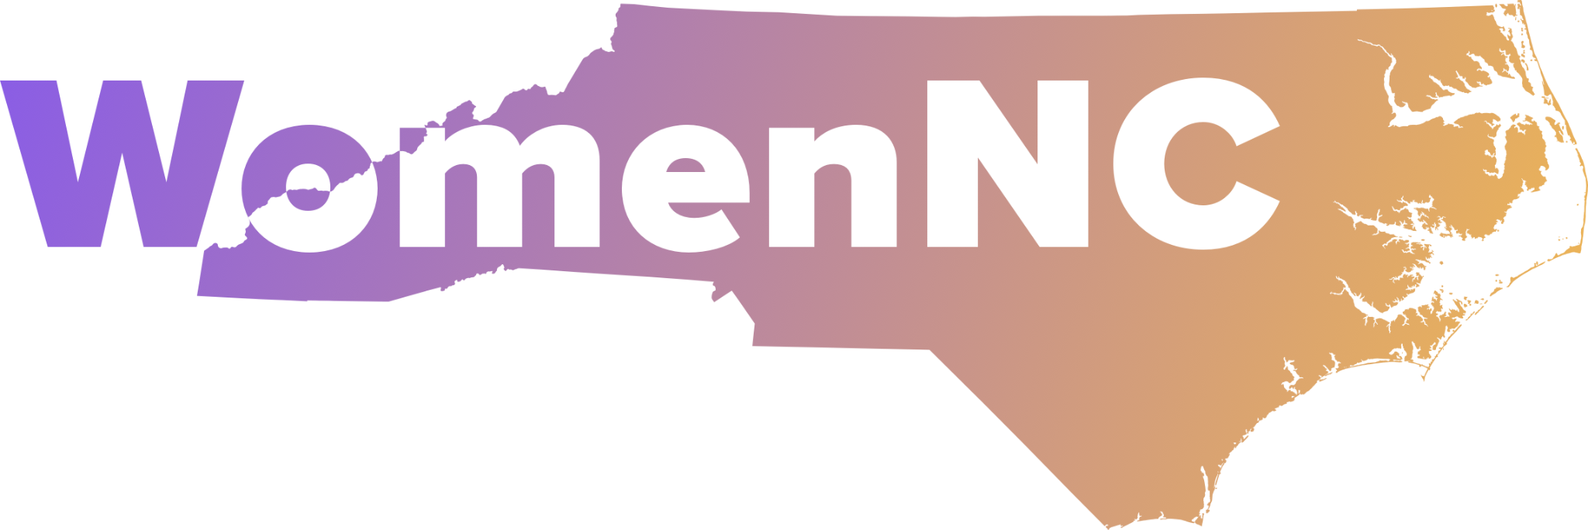
PO Box 33441, Raleigh, NC 27636

Empowering the next generation to advance gender equality in North Carolina.

WomenNC Youth Leaders for Change Training Program
Empowering High School Juniors and Seniors | A 9-Month Journey (September – May)

Mission
The WomenNC Youth Leaders for Change Training Program is a transformative, 9-month initiative for high school juniors and seniors in North Carolina. From September through May, students gain essential leadership and professional development skills while fostering a passion for advocacy and community impact.
Our goal is to build a pipeline between high school and college leadership. Graduates of this program are encouraged to apply to the WomenNC College Scholars Program, continuing their growth as advocates for gender equity.

Core Program Components
Students will build confidence and gain real-world experience through workshops and mentorship in:
- Public Speaking and Effective Communication
- Networking and Professional Development
- Advocacy and Civic Engagement
- Running for Public Office
- Community Outreach Strategies
- Financial Literacy and Empowerment
Each student will also serve as an active member of one of WomenNC’s working committees:
- Fund Development
- Social Media and Communications
- Events and Programming
- Community Outreach and Marketing
This hands-on involvement allows students to apply their skills to meaningful projects while receiving guidance from experienced professionals and community leaders.

Recognition and Opportunity
- In December, all participants will complete a formal evaluation.
- Two outstanding students will be selected to attend a national Youth Leadership Conference in Washington, D.C.
  - Travel and accommodations are fully funded by WomenNC.
  - Selected students will engage with national leaders, youth advocates, and changemakers from across the country.

Program Timeline
Milestone | Date
Application Opens | April 1
Application Deadline | June 1
Selection and Notification | July 15
Orientation | September 1
Program Start Date | September 1
Program Completion | June 1

Eligibility Criteria
Applicants must:
- Be a current high school junior or senior
- Attend school in Orange, Durham, or Wake County
- Have a minimum GPA of 3.0
- Demonstrate leadership potential and a commitment to community service
- Be available to fully participate from September through June, including mandatory attendance at the October Kickoff Event and the February Local to Global Forum

Why Join?
- Build lifelong leadership and advocacy skills
- Make a real impact in your community
- Join a dynamic network of youth leaders
- Be on the path to becoming a WomenNC College Scholar

