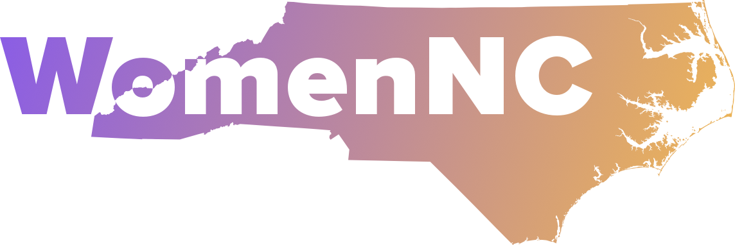
PO Box 33441, Raleigh, NC 27636

Empowering the next generation to advance gender equality in North Carolina.
WomenNC Youth Leadership Program
Parent/Guardian Permission Form (Virtual Workshops Only)
If your child is under 18, please complete this form.

Student Name: _________________________________________
Date of Birth: __________________________________________
School Name: _________________________________________
Grade Level (Circle One): Junior | Senior
City/State: _____________________________________________

Program Overview
The WomenNC Youth Leadership Program is a national, fully virtual leadership development initiative for emerging youth leaders from age 16-24 across the United States. Students will collaborate with other high school and college students, and young professionals to build leadership, advocacy, and civic engagement skills through a series of selected virtual workshops held from September 2026 to May 2027.
Participation Requirement:
Students will participate in selected virtual workshops, including, but not limited to (all in Eastern Time, on Sundays):
- September: Leadership Workshop
- November: Advocacy Training Workshop
- January: Public Speaking and Networking Skills Workshop
- February: Global Gender Justice Platform (UN CSW) Workshop

Consent & Emergency Information
Parent/Guardian Name: ___________________________________
Phone Number: __________________________________________
Email: __________________________________________________

Permissions
Please check all that apply:
☐ I give permission for my child to participate in the selected virtual WomenNC Youth Leadership Program workshops from September 2026 through May 2027.
☐ I understand that my child will participate in workshops via secure platforms (e.g., Zoom) alongside other high school and college students, and young professionals.
☐ I give permission for my child’s photo (as submitted or taken in virtual sessions), name, or written content to be shared in WomenNC’s communications (e.g., newsletters, reports, social media).
(Optional – uncheck to opt out.)
☐ I give participation for WomenNC to communicate with my child via email or text related to this program.
☐ I understand that it is my responsibility to ensure my child has access to a reliable internet connection and device for participation.

Liability Release
☐ I release and hold harmless WomenNC, its staff, board members, and volunteers from any and all liability related to my child’s participation in this virtual workshop series.

Signatures
Parent/Guardian Signature: _____________________________
Date: ___________________
Student Signature: ___________________________________
Date: ___________________

