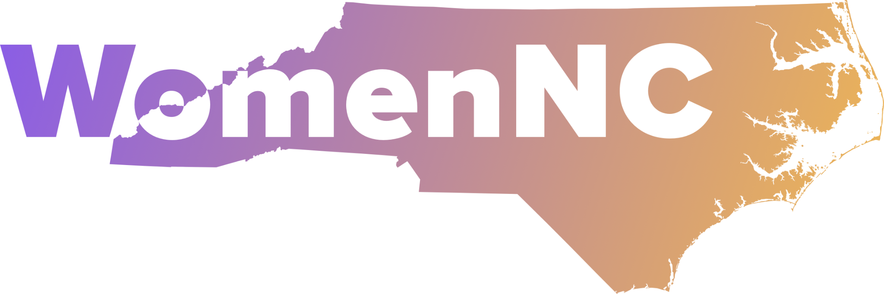
PO Box 33441, Raleigh, NC 27636

Empowering the next generation to advance gender equality in North Carolina.

WomenNC Youth Leadership for Change Program Application
For High School Juniors & Seniors (September – June)
Deadline: June 1, 2026 | Notification: July 15 | Program Begins: September 1
Eligibility: Applicants must be juniors or seniors enrolled in high schools located in Orange, Wake, or Durham counties in North Carolina. A minimum GPA of 3.0 is required. Attendance at the October Kickoff Event and Local to Global Forum in February is mandatory.

Applicant Information
- Full Name: _______________________________________
- Preferred Name (if different): ______________________
- Date of Birth: _____________________________________
- Current Grade Level: ☐ Junior ☐ Senior
- GPA: __________
- High School Name: _________________________________
- County: ☐ Orange ☐ Wake ☐ Durham
- Home Address: ____________________________________
- City/State/ZIP: ____________________________________
- Student Email: _____________________________________
- Phone Number: ____________________________________

Parent/Guardian Information
- Parent/Guardian Full Name: __________________________
- Phone Number: ____________________________________
- Email Address: _____________________________________
- Relationship to Student: _____________________________

Supporting Materials
- Resume (PDF preferred)
Upload a current resume outlining your educational background, extracurricular activities, awards, and leadership experience.
☐ I have uploaded my resume.
- Letter of Recommendation (PDF preferred)
Please include the name and relationship of your recommender (teacher required). They should email their letter directly to: danielle.goetz@womennc.org by June 1, 2026.
- Community Involvement
List up to three community service or leadership activities you’ve participated in.
Activity 1:
- Name: _______________________________
- Description: __________________________
- Dates: _______________________________
Activity 2:
- Name: _______________________________
- Description: __________________________
- Dates: _______________________________
Activity 3:
- Name: _______________________________
- Description: __________________________
- Dates: _______________________________

Essay Question (500–750 words)
Prompt:
What role do you believe youth should play in creating positive change at the local (North Carolina), national, and global levels? How do you see yourself contributing to this change through WomenNC’s Youth Leadership Program?
☐ I have attached my essay (typed on a separate page).

Commitment Agreement
If selected, I understand I will be expected to:
- Attend all required workshops and events (in-person or virtual) from September to June
- Participate in both the October Kickoff Event and Local to Global Forum in February
- Actively serve on a WomenNC working committee
- Represent WomenNC with professionalism and enthusiasm
- Travel to events in NC or Washington, D.C. if selected (expenses covered)
☐ I agree to the terms and commit to the program.
Applicant Signature: ________________________ Date: __________
Parent/Guardian Signature: ___________________ Date: __________

Equal Opportunity Statement
WomenNC is an equal opportunity organization. We welcome applicants of all backgrounds regardless of race, ethnicity, gender identity, sexual orientation, ability, religion, or socioeconomic status.

