
Petition of Solidarity with WomenNC in their support of People of Iran

We stand with WomenNC in their steadfast support for the Iranian people—especially women and youth, as they continue their struggle for freedom, democracy, human rights, and equality.
For decades, Iranian women have resisted compulsory laws, systemic discrimination, and state violence. Their leadership in protests, community organizing, and human rights advocacy has been central to the broader movement for dignity, equality, and accountable governance.
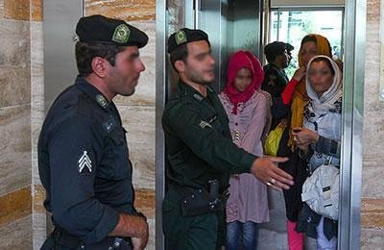
Iran’s diverse ethnic and religious communities—including Kurdish, Baluchi, Arab, Azeri, and Turkmen populations—remain integral to the country’s social fabric. Yet these groups continue to face longstanding discrimination and disproportionate state violence. Women from these marginalized communities experience dual injustices: gender-based repression alongside ethnic and religious discrimination. Activists, students, and mothers of detainees from these communities are frequently subjected to intimidation, arbitrary arrest, and harsh sentencing.
We are concerned by recent statements from Reza Pahlavi, the son of Iran’s former dictator monarch, who is attempting to leverage the Iranian uprising to position himself for a return to monarchical rule. In these statements, he labels Kurdish political groups as “separatist” and implies the need for suppression. Such rhetoric reinforces security driven narratives that have historically been used to justify crackdowns on ethnic minorities. When legitimate political expression is framed as a security threat, women activists from these communities are often among the first to suffer the consequences.
We affirm that the rights of all women in Iran, across every nationality and faith—must be protected. Advocacy for equality, political participation, and autonomy within a democratic and unified Iran is fully consistent with international human rights principles. Any vision for Iran’s future must uphold women’s equality, pluralism, and the rule of law.
We call on civil society organizations, academic institutions, policymakers, democratic governments, and individuals of conscience to stand with Iranian women in all their diversity. We urge international bodies, including the UN Commission on the Status of Women, to closely monitor the situation of women from marginalized communities and to reject rhetoric that may legitimize further repression.
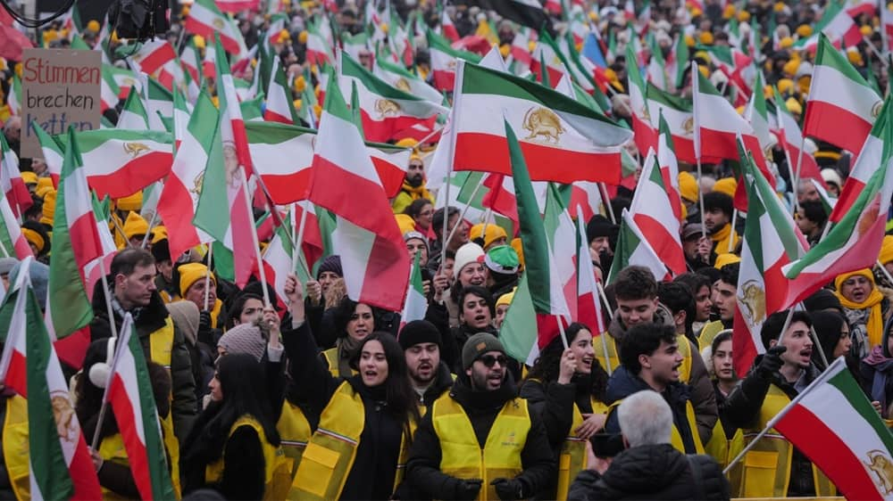
The struggle of Iranian women, supported by courageous young people across all ethnic and religious communities, is a struggle for universal human dignity.

We stand with them.

